**Web Programming**

Lab - 7

CSS

Name: Sushen Grover

Reg No: 23BCE1728

Slot: L11+L12+L31+L32

Class No: CH2024250502774

Course Code: BCSE203E

Faculty: Dr. L.M. Jenila Livingston

Question 1:

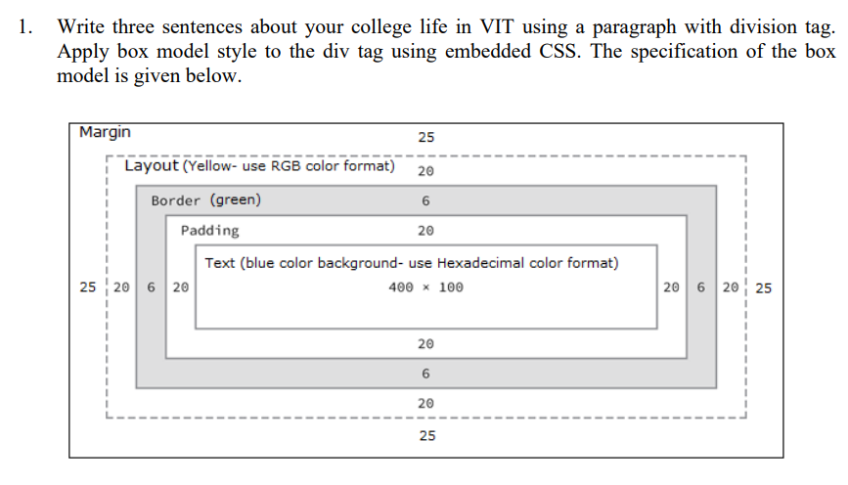

Code:

<!DOCTYPE html>

<html lang="en">

<head>

    <meta charset="UTF-8">

    <meta name="viewport" content="width=device-width, initial-scale=1.0">

    <title>23BCE1728</title>

    <style>

        *{

            background-color: #FFFF00;

        }

        div{

            width: 400px;

            height: 100px;

            padding: 20px;

            border: 6px solid #00FF00;

            margin: 25px;

            background-color: #0000FF;

            font-size: 14px;

            text-align: justify;

            color: #FFFFFF;

        }

    </style>

</head>

<body>

    <h1>Exercise 7A</h1>

    <div>

        Life at VIT Chennai is a blend of academic challenges, exciting opportunities, and personal growth. The vibrant campus offers diverse clubs and hackathons to explore my interests. I've also built lasting friendships while preparing for a bright future.

    </div>

</body>

</html>

Output:

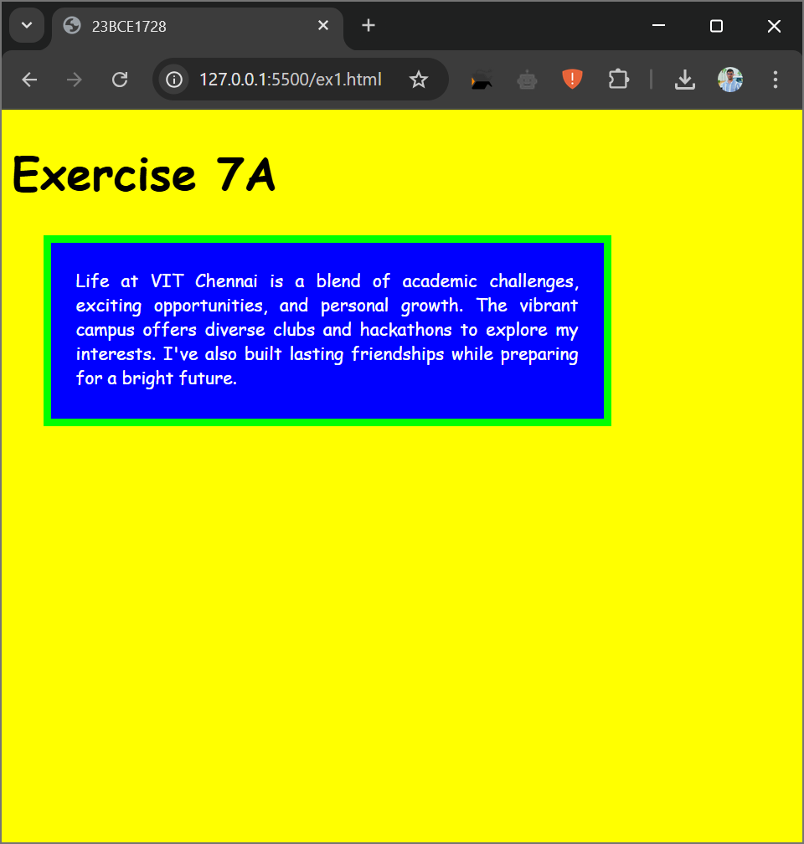

Question 2:

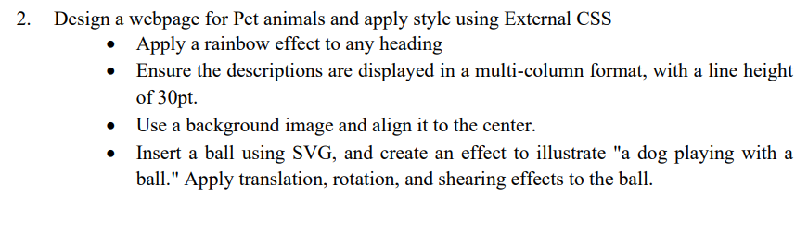

Code:

HTML

<!DOCTYPE html>

<html lang="en">

<head>

    <meta charset="UTF-8">

    <meta name="viewport" content="width=device-width, initial-scale=1.0">

    <title>23BCE1728</title>

    <link rel="stylesheet" type="text/css" href="ex2.css">

</head>

<body>

    <h1>Exercise 7B</h1>

    <hr>

    <h3>Welcome to the world of pets</h3>

    <div id="content">

        Pet animals have been cherished companions to humans for centuries, offering love, loyalty, and a sense of comfort. From dogs and cats to birds, rabbits, and even exotic pets like reptiles, these animals bring joy to countless households around the world. Each type of pet has unique qualities, but they all share one common trait: their ability to form strong bonds with their owners.

        Dogs, often referred to as "man's best friend," are known for their loyalty and protective nature. They are playful, affectionate, and can be excellent companions for individuals and families. Cats, on the other hand, are independent yet loving, often enjoying quiet moments of companionship. Birds like parrots and canaries captivate owners with their vibrant colors and melodious chirping. Small pets such as rabbits, hamsters, and guinea pigs are gentle and low-maintenance, making them ideal for young children.

        Caring for a pet teaches responsibility, empathy, and discipline. Feeding, grooming, and ensuring their health and well-being can instill important life skills. Pets also have therapeutic effects on humans, helping to reduce stress, anxiety, and loneliness. Studies have shown that interacting with pets can lower blood pressure and boost overall mental health.

        However, owning a pet is a significant commitment. Pets depend on their owners for food, shelter, and emotional care. Before bringing a pet home, it’s essential to consider factors such as lifestyle, living space, and the time required to care for the animal.

        In return for your care, pets provide unconditional love and companionship. Whether it’s a wagging tail, a soothing purr, or cheerful chirping, pet animals enrich lives in countless ways and become an inseparable part of the family.

    </div>

    <div id="dog">

        <img src="dog-clipart-md.png" width="100px" alt="">

    </div>

    <div class="svg-container">

        <svg width = "500px" height = "300px">

            <g class = "ball-group">

            <circle cx = "50" cy = "50" r = "30" stroke = "black" stroke-width = "5px" fill = "red"/>

            <polygon points = "50, 40 60, 50 50, 60 40, 50" style = "fill:yellow"/>

            </g>

        </svg>

    </div>

</body>

</html>

CSS

svg{

    overflow : visible;

}

@keyframes ball-animation {

    0% {

        transform: translate(0px, 0px) rotate(0deg) matrix(1, 0, 0, 1, 0, 0); /* No movement */

    }

    25% {

        transform: translate(50px, 50px) rotate(45deg) matrix(1, 0.5, 0, 1, 0, 0); /* Shear */

    }

    50% {

        transform: translate(100px, 50px) rotate(90deg) matrix(1, 0, 0.5, 1, 0, 0); /* Combined shear */

    }

    75% {

        transform: translate(50px, 100px) rotate(135deg) matrix(1, -0.5, 0, 1, 0, 0); /* Reverxse shear */

    }

    100% {

        transform: translate(0px, 0px) rotate(360deg) matrix(1, 0, 0, 1, 0, 0); /* Reset */

    }

}

.ball-group{

    animation : ball-animation 5s infinite;

}

.svg-container{

    position: absolute;

    top:940px;

    left:550px;

    display : flex;

    justify-content: center;

}

h3{

    background-image: linear-gradient(to left,violet,indigo,blue,green,yellow,orange,red);

    -webkit-background-clip: text;

    -webkit-text-fill-color: transparent;

    font-size: 40px;

}

#content{

    column-count: 3;

    column-rule: 2px solid black;

    line-height: 30pt;

    background-image: url(output-onlinepngtools.png);

    background-size: cover;

    text-align: justify;

    padding: 10px;

}

#dog{

    position:absolute;

    top:1100px;

    left:500px;

}

Output:

